
DIABETES PREDICTION PROJECT

Final Report

Sprints 1, 2 & 3
Data Preprocessing, Neural Networks, and Explainable AI

Group 4

Hawiana Bedada
Junior Adnan
Jennifer Stephen

Table of Contents
Table of Contents 2
1. Introduction 4
2. Data Preprocessing 5
2.1 First Look at the Data 5
2.2 Fixing the Target Variable 6
2.3 Feature Types 7
2.4 Train/Validation/Test Split 7
3. Ethical Considerations 9
3.1 What We Kept: Sex and Age 9
3.2 What We Removed: Education and Income 9
4. Correlation Analysis 10
4.1 What Correlates with Diabetes? 10
4.2 Correlation Heatmap 10
5. Choosing the Right Metrics 12
5.1 Why ROC AUC? 12
5.2 Why Recall Matters for Healthcare 12
6. Neural Network Architecture 13
6.1 Why MLP? 13
6.2 The Experiment 13
6.3 Results 13
6.4 What We Learned 14
7. Carbon Footprint and Sustainability 16
7.1 Why Track Emissions? 16
7.2 How CodeCarbon Works 16
7.3 Our Results 16
7.4 Picking the Final Architecture 17
8. Handling Class Imbalance 18
8.1 The Problem 18
8.2 Our Solution: Class Weights 18
8.3 Why We Didn't Use SMOTE 18
9. Decision Threshold Optimization 19
9.1 The Default Isn't Always Best 19
9.2 Exploring Different Thresholds 19
10. Model Enhancements 21
10.1 Regularization Techniques 21
10.2 Preventing Overfitting 21
10.3 Enhanced Model Results 21
11. Explainable AI 23
11.1 Why Explainability Matters 23
11.2 SHAP 23
11.3 LIME 24
11.4 What the Model Learned 24
12. Final Results 25
12.1 Test Set Performance 25
12.2 Confusion Matrix 25
12.3 Comparison with Traditional ML 26
13. Conclusion 27
13.1 What We Built 27
13.2 Key Decisions 27
13.3 Limitations 27
13.4 Future Work 27

1. Introduction
This report walks through our work on building a machine learning model that predicts diabetes risk. We used the BRFSS 2015 health survey dataset, which has responses from over 253,000 people across the United States. The survey captures all sorts of health indicators and lifestyle factors that could be relevant for predicting diabetes.
The main goal was to build a neural network that does well on ROC AUC, which is the metric we were asked to optimize. But along the way, we also wanted to make sure the model is fair, efficient, and actually explainable to doctors and patients who might use it.
The work was in three sprints:
Sprint 1 was about getting the data ready. We cleaned it up, figured out which features to keep, and made some ethical decisions about sensitive variables like income and education.
Sprint 2 focused on building and comparing different neural network architectures. We tested 16 different configurations to see what actually works best for this kind of tabular health data.
Sprint 3 added the finishing touches: tracking carbon emissions to be environmentally conscious, handling the class imbalance problem properly, tuning the decision threshold, and making the model explainable with SHAP and LIME.
What follows is a detailed account of what we did, why we made certain choices, and what we learned along the way.

2. Data Preprocessing

2.1 First Look at the Data
The BRFSS dataset came with 253,680 rows and 22 columns. One column is the target (diabetes status), and the rest are potential features. Everything was already numeric since survey responses get coded that way, so we didn't need to worry about categorical encoding.
We checked for missing values and found none, which was nice. The BRFSS folks do a good job with data quality. We did find about 24,000 duplicate rows, but after thinking about it, we kept them. These are just different people who happened to answer the survey the same way, not actual data errors.

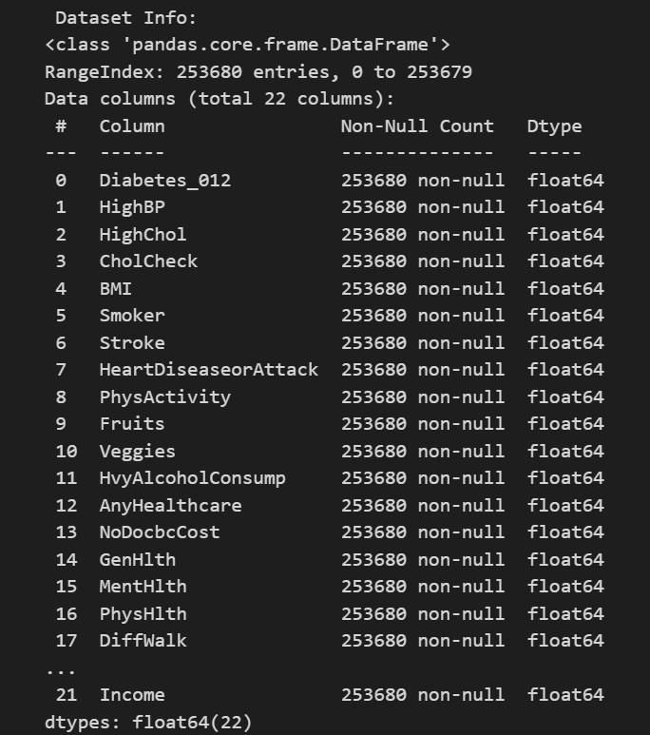
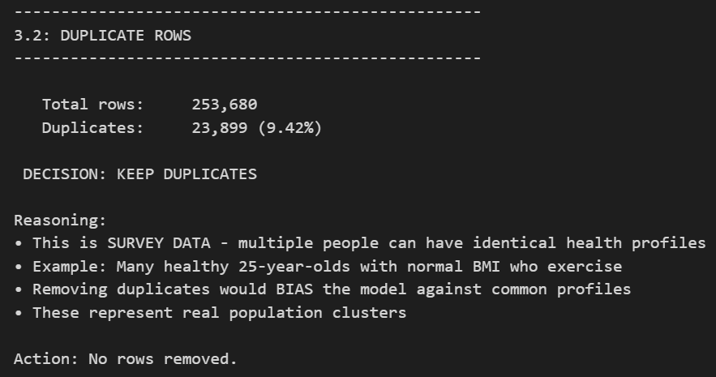
Figure 2.1: Dataset info and initial exploration

2.2 Fixing the Target Variable
The original target had three classes: 0 for no diabetes, 1 for prediabetes, and 2 for diabetes. We decided to make it binary by lumping no-diabetes and prediabetes together as 0, and keeping diabetes as 1.
Why? Because prediabetes is reversible with lifestyle changes. Someone with prediabetes doesn't need medical treatment yet. But someone with actual diabetes does. So clinically, it makes more sense to build a model that identifies people who currently have diabetes and need help now.
After this change, we ended up with about 86% non-diabetic and 14% diabetic. That's roughly a 6:1 imbalance, which we had to deal with later.

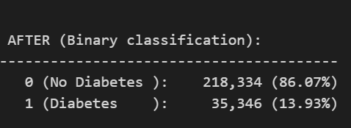
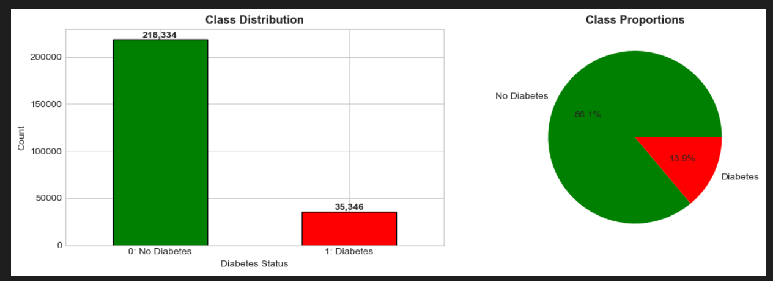
Figure 2.2: Class distribution after target transformation

2.3 Feature Types
We grouped our features into three buckets:
Type | Count | Examples
Binary (yes/no) | 14 | HighBP, Smoker, PhysActivity, Sex
Ordinal (ordered categories) | 4 | GenHlth (1-5), Age (1-13)
Continuous (numbers) | 3 | BMI, MentHlth, PhysHlth

2.4 Train/Validation/Test Split
We split the data 70/15/15 for training, validation, and testing. We used stratified sampling so each split has roughly the same proportion of diabetics. Then we scaled the continuous features using StandardScaler, fitting only on training data to avoid leakage.

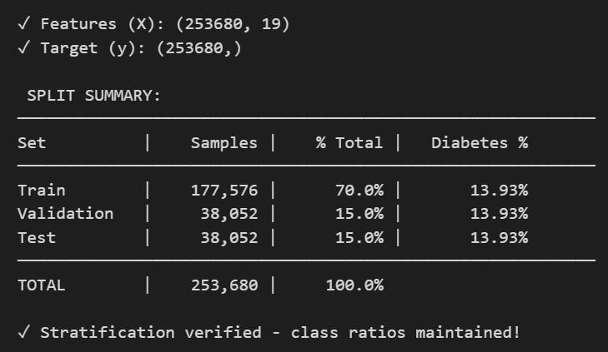
Figure 2.3: Data split sizes

3. Ethical Considerations
Healthcare models can have real consequences. They might influence who gets screened, who gets treatment, or even insurance decisions. So we spent some time thinking about which features are okay to use and which ones might cause harm.

3.1 What We Kept: Sex and Age
We kept Sex and Age because they have genuine biological relevance to diabetes. Men and women have different hormone profiles that affect metabolism. And diabetes risk genuinely goes up as you get older because your pancreas becomes less efficient. The medical literature backs this up.

3.2 What We Removed: Education and Income
We removed Education and Income. Yes, statistically they correlate with diabetes rates. But here's the thing: there's no biological reason why having less money would cause diabetes. The correlation exists because lower income often means less access to healthy food, less time for exercise, worse healthcare access, and more stress. These are social factors, not medical ones.
If we left these in, the model might learn to flag poor people as high risk. That could lead to discriminatory outcomes, like insurance companies charging more to people who are already disadvantaged. A screening tool should identify actual medical risk factors, not economic circumstances.
After removing these two, we went from 21 features down to 19.

4. Correlation Analysis
Before training any models, we wanted to understand how the features relate to each other and to diabetes.

4.1 What Correlates with Diabetes?
The strongest positive correlations (meaning higher values = higher diabetes risk) were GenHlth, HighBP, Age, BMI, and HighChol. This makes sense medically. People who report poor general health, have high blood pressure, are older, heavier, or have high cholesterol are more likely to have diabetes.
On the flip side, PhysActivity, Fruits, and Veggies had negative correlations. People who exercise and eat well are less likely to be diabetic. Again, no surprises here.

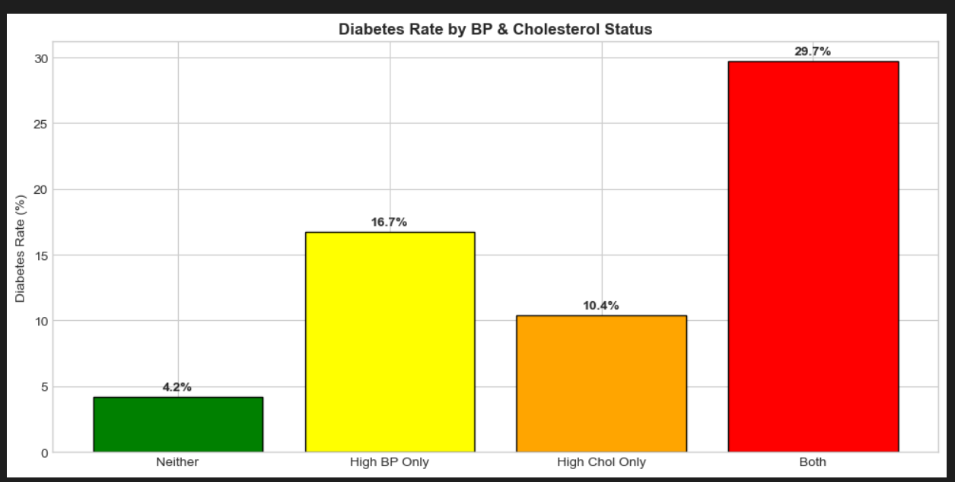Figure 4.1: Feature correlations with diabetes target

4.2 Correlation Heatmap
We also looked at how features correlate with each other. This helps spot multicollinearity (when two features basically measure the same thing) and gives a sense of the data structure.

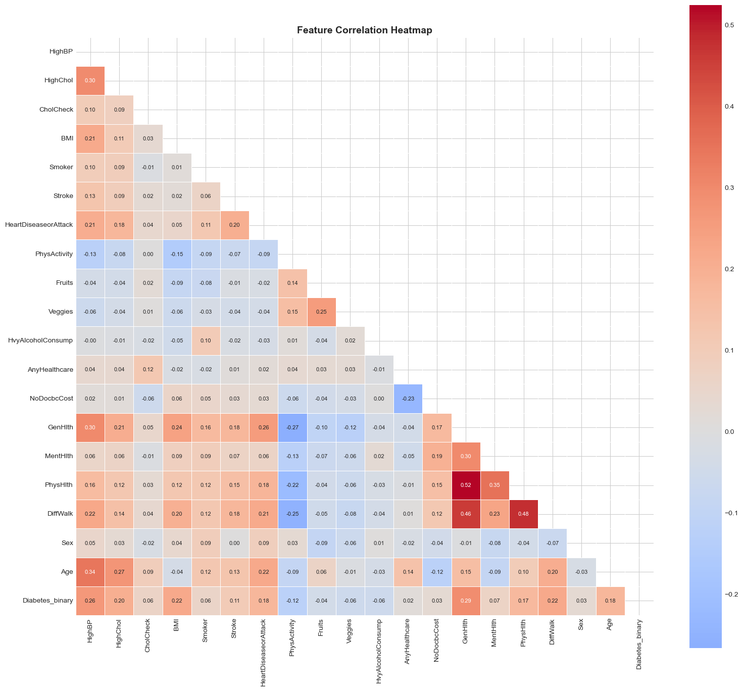Figure 4.2: Full correlation heatmap

5. Choosing the Right Metrics

5.1 Why ROC AUC?
Our primary metric is ROC AUC, and there are good reasons for this. With an 86/14 class split, accuracy is basically useless. A model that just predicts 'not diabetic' for everyone would get 86% accuracy while catching zero actual diabetics.
ROC AUC doesn't have this problem. It measures how well the model ranks diabetics above non-diabetics, regardless of what threshold you use. A random model gets 0.5, a perfect model gets 1.0.

5.2 Why Recall Matters for Healthcare
Beyond AUC, we care a lot about Recall in this context. Here's why:
Mistake | What Happens | How Bad?
Miss a diabetic (False Negative) | Person goes untreated, develops complications | Really bad
False alarm (False Positive) | Person gets an extra blood test | Minor inconvenience

Missing someone who actually has diabetes can lead to blindness, kidney failure, amputations, or worse. A false alarm just means someone gets a $20 blood test. The costs are completely asymmetric, so we'd rather catch more diabetics even if it means more false alarms.

6. Neural Network Architecture

6.1 Why MLP?
For tabular data like this, the right architecture is a Multilayer Perceptron (MLP). CNNs are for images, RNNs are for sequences. Health survey data is just a table of numbers, so a plain feedforward network is the way to go.

6.2 The Experiment
Rather than guessing at an architecture, we tested 16 different ones systematically. We varied both depth (1 to 4 hidden layers) and width (tiny to large):
Depth | Tiny | Small | Medium | Large
1 Layer | [16] | [32] | [64] | [128]
2 Layers | [32, 8] | [32, 16] | [64, 32] | [128, 64]
3 Layers | [32,16,4] | [32,16,8] | [64,32,16] | [128,64,32]
4 Layers | [32,16,8,2] | [32,16,8,4] | [64,32,16,8] | [128,64,32,16]

All models used the same settings: 30% dropout, batch size of 256, ReLU activation, and Adam optimizer with learning rate 0.001.

6.3 Results

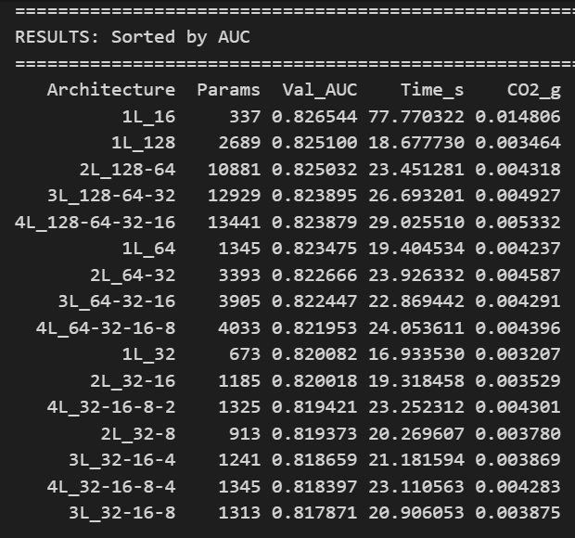
Figure 6.1: Architecture comparison results table

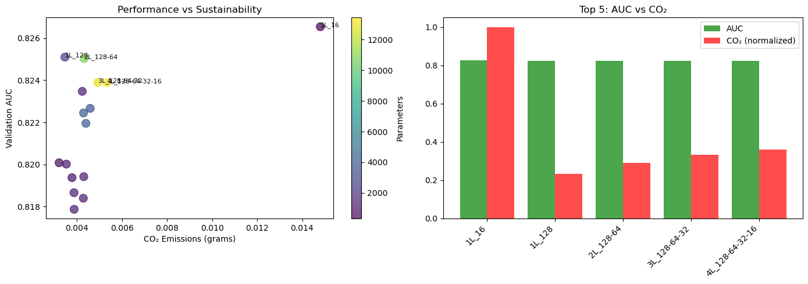Figure 6.2: Architecture comparison visualization

6.4 What We Learned
The results were a bit surprising: simpler is better. The single-layer network with 128 neurons beat all the deeper architectures. Performance actually got worse as we added more layers.
This isn't unusual for tabular data. The patterns in health surveys are fundamentally simpler than patterns in images or text. Adding depth just adds opportunities for overfitting without capturing any useful complexity.

7. Carbon Footprint and Sustainability

7.1 Why Track Emissions?
Training neural networks uses electricity, and electricity generation produces CO2. It might seem small for one model, but across the whole AI industry it adds up. We used CodeCarbon to track our emissions because it's good practice and because it helped us make a better architecture choice.

7.2 How CodeCarbon Works
CodeCarbon monitors your CPU/GPU power usage during training, multiplies by duration, and converts to CO2 using regional carbon intensity factors. The formula is simple:
CO2 (kg) = Energy (kWh) × Carbon Intensity (kg CO2/kWh)

7.3 Our Results

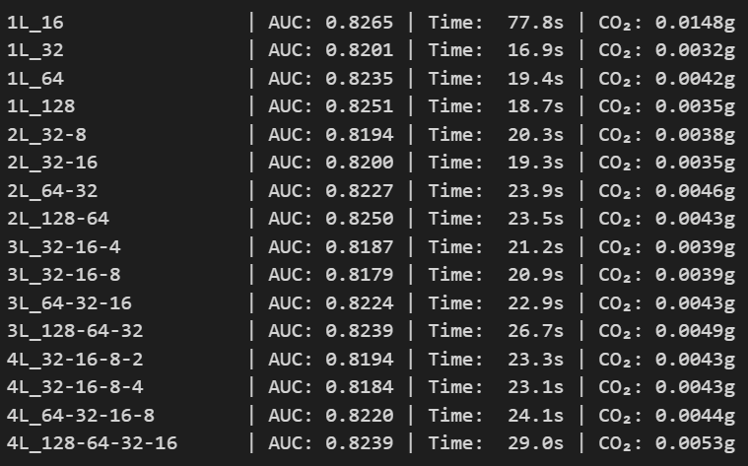
Figure 7.1: Carbon footprint results for all architectures

7.4 Picking the Final Architecture
Looking at the results, 1L_16 had the highest AUC (0.8265) but also the highest emissions and took 77 seconds to train. That long training time suggests unstable convergence.
We went with 1L_128 instead. It scores 0.8251 AUC (only 0.14% lower), uses 4x less energy, and trains 4x faster. The tiny performance difference doesn't justify the environmental cost.
Metric | 1L_16 (highest AUC) | 1L_128 (our choice)
Validation AUC | 0.8265 | 0.8251
CO2 emissions | 0.0148g | 0.0035g
Training time | 77 seconds | 18.7 seconds
Efficiency score | 55.5 | 231.5

8. Handling Class Imbalance

8.1 The Problem
We have about 6 non-diabetics for every 1 diabetic in our data. Without doing anything about this, the model would learn to mostly predict 'not diabetic' since that's the easy way to minimize loss.

8.2 Our Solution: Class Weights
We used class weights to make diabetic samples count more during training. Specifically, misclassifying a diabetic costs 6.2x more than misclassifying a non-diabetic. This forces the model to pay attention to the minority class.
Class | Weight | What It Means
0 (No Diabetes) | 1.0 | Normal penalty
1 (Diabetes) | 6.2 | 6.2x penalty for errors

8.3 Why We Didn't Use SMOTE
SMOTE is a popular technique that creates synthetic samples of the minority class. We deliberately chose not to use it for this project, and here's why:
First, medical data should represent real patients. Synthetic samples are interpolations that might have feature combinations that don't actually occur in real people. Imagine a synthetic patient who has the blood pressure of a 25-year-old but the BMI trajectory of someone who's been obese for 40 years. That person doesn't exist.
Second, there are regulatory and ethical concerns. If this model ever got used in a clinical setting, regulators might not look kindly on a model trained partly on fake patient records.
Class weights achieve the same goal of balancing the classes without inventing data that doesn't exist.

9. Decision Threshold Optimization

9.1 The Default Isn't Always Best
By default, we'd predict 'diabetic' when the model outputs a probability above 0.5. But with imbalanced data and asymmetric error costs, 0.5 might not be optimal.

9.2 Exploring Different Thresholds
We tried thresholds from 0.1 to 0.9 and looked at how recall and precision change:

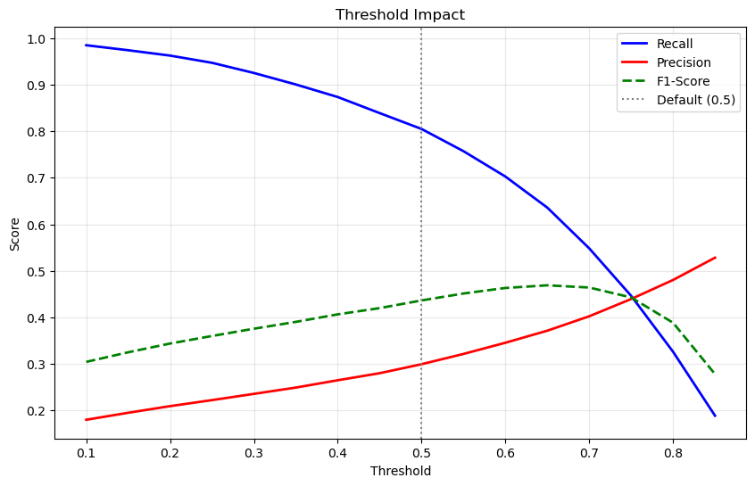
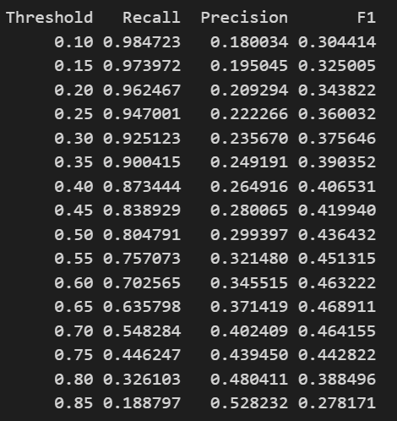
Figure 9.1: Threshold vs Recall/Precision/F1 curves
Threshold | Recall | Precision | F1
0.20 | 0.96 | 0.21 | 0.34
0.30 | 0.93 | 0.24 | 0.38
0.35 | 0.90 | 0.25 | 0.39
0.50 (default) | 0.80 | 0.30 | 0.44

Lower thresholds catch more diabetics but also trigger more false alarms. We picked a threshold that maximizes recall while keeping precision above 0.25. Going lower than that would mean flagging way too many healthy people.
Our best threshold for the model was 0.35.
- Recall: 90% (catches 9 out of 10 diabetics)
- Precision: 25% (acceptable false alarm rate)

10. Model Enhancements

10.1 Regularization Techniques
We added several techniques to make the model more robust:
Batch Normalization: Normalizes activations between layers. This stabilizes training and lets us use higher learning rates.
L2 Regularization: Penalizes large weights (strength = 0.001). This discourages the model from relying too heavily on any single feature.
LeakyReLU: Like ReLU but allows small negative values. Helps avoid 'dead neurons' that stop learning.
Learning Rate Scheduling: Automatically reduces the learning rate when validation performance plateaus.

10.2 Preventing Overfitting
Overfitting is when the model memorizes the training data instead of learning generalizable patterns. We used multiple defenses:
Technique | How It Helps
Early Stopping | Stops training when validation AUC stops improving
Dropout (30%) | Randomly disables neurons during training
L2 Regularization | Keeps weights small
Validation Monitoring | We always watch validation metrics, not training metrics

10.3 Enhanced Model Results

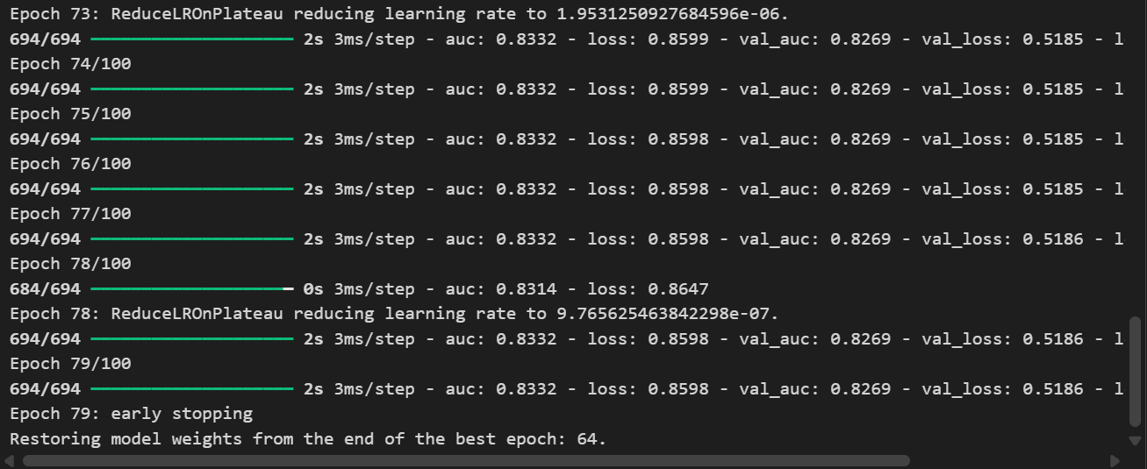Figure 10.1: Training curves (loss and AUC over epochs)

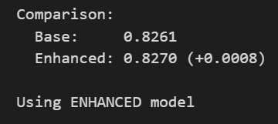
Figure 10.2: Base vs Enhanced model comparison

11. Explainable AI

11.1 Why Explainability Matters
A model that just outputs a number isn't very useful in healthcare. Doctors want to know why a patient is flagged as high risk. Patients want to understand what they can do about it. Regulators want to verify the model isn't doing something sketchy.
We implemented two explainability methods: SHAP and LIME.

11.2 SHAP
SHAP (SHapley Additive exPlanations) comes from game theory. It calculates how much each feature contributes to pushing the prediction away from the average. You can use it for global explanations (which features matter overall) or local explanations (why this specific patient got this prediction).

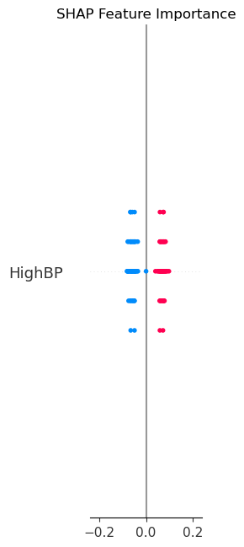
Figure 11.1: SHAP summary plot (global feature importance)

11.3 LIME
LIME (Local Interpretable Model-agnostic Explanations) works differently. It creates a simple linear model that approximates the neural network's behavior around a specific prediction. This gives you an easy-to-understand explanation for individual cases.

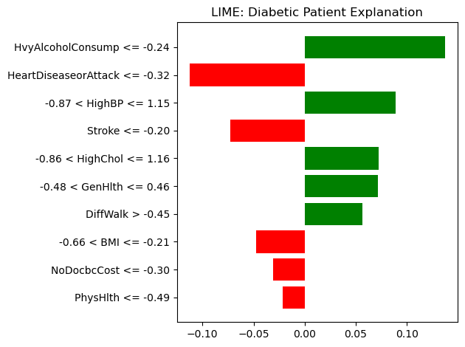Figure 11.3: LIME explanation for a diabetic patient

11.4 What the Model Learned
This chart shows why the model predicted this specific patient as diabetic. Each bar shows how much a feature pushed the prediction toward diabetes (green) or away from it (red).
This is reassuring. The model learned real medical patterns, not spurious correlations or proxies for sensitive attributes.

12. Final Results

12.1 Test Set Performance

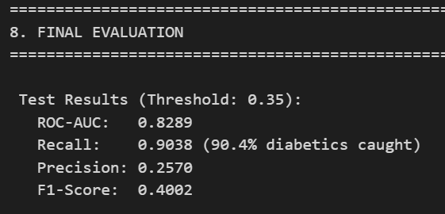
Figure 12.1: Final model evaluation metrics
Metric | Score | What It Means
ROC-AUC | 0.8289 | Good ranking ability
Recall | 0.9038 | Catches most diabetics
Precision | 0.2570 | Some false alarms (acceptable trade-off)
F1-Score | 0.4002 | Reasonable balance

12.2 Confusion Matrix

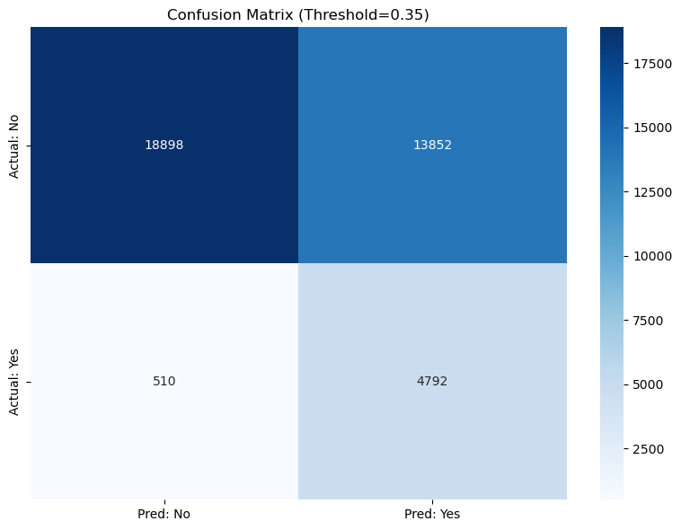Figure 12.2: Confusion matrix

12.3 Comparison with Traditional ML
We also tested Logistic Regression and Random Forest to see if the neural network actually adds value:
Model | ROC-AUC | Notes
Neural Network | 0.8289 | Best, but marginal advantage
Random Forest | 0.8248 | Nearly identical
Logistic Regression | 0.8207 | Simplest, lowest carbon

Honestly, the differences are tiny. For tabular health data like this, fancy models don't buy you much over simple ones. If someone wanted to deploy this at scale and cared about efficiency, Logistic Regression would be a perfectly reasonable choice.

13. Conclusion

13.1 What We Built
We built a neural network that predicts diabetes risk with an AUC of 0.8289. It's not perfect, but it's good enough to be useful as a screening tool. More importantly, it's explainable, efficient, and built with ethical considerations in mind.

13.2 Key Decisions
Decision | What We Chose | Why
Architecture | 1L_128 (single layer, 128 neurons) | Best AUC/efficiency trade-off
Class Imbalance | Class weights (6.2x) | No fake patients
Sensitive Features | Removed Education/Income | Prevent discrimination
Primary Metric | ROC-AUC | Handles imbalance properly
Explainability | SHAP + LIME | Doctors need to understand

13.3 Limitations
We should be honest about what this model can't do:
It's trained on US survey data from 2015. It might not generalize to other countries or to 2024.
It predicts risk based on self-reported health factors, not lab tests or genetic markers.
With ~30% precision at our chosen threshold, about 70% of people flagged as high-risk are actually fine. That's a lot of unnecessary worry and follow-up tests.

13.4 Future Work
If we had more time, we'd want to:
Test on more recent data to see if the patterns still hold.
Try ensemble methods that combine neural networks with tree-based models.
Build an actual interface that doctors could use.
Validate on external datasets from different populations.

Overall, this project gave us a solid foundation for understanding how to build ML models for healthcare applications while being mindful of fairness, sustainability, and explainability.

